

Specification

for

History Browser (Marfa 5.1)

Trent Miskelly

11/1/07



Proprietary and Confidential to BBS Technologies, Inc.

© 2006 BBS Technologies, Inc.; all rights reserved.

Revision history:
When? | Who? | What?
11/1/2007 | Trent Miskelly | First Draft – for review
11/6/2007 | Trent Miskelly | Final Draft

Table of Contents
1. Revision history: ii
2. Table of Contents iii
3. Requirements 1
3.1. Overview/Purpose 1
3.1.1. Related Customer Requests 1
3.2. Target Users 1
3.3. Feature/Function Market Requirements 2
3.3.1. Required Functions 2
3.3.2. Non-Supported Functions 3
3.4. FAQ 4
3.5. Open Issues 4
4. Functional Design 5
4.1. User Interfaces 5
4.1.1. Configuring collection 5
4.1.2. Configuring grooming 5
4.1.3. Browsing historical snapshots 6
4.1.4. Switching to Real-Time mode from History Mode 14
4.1.5. Viewing historical snapshots for specific alerts 14
4.2. Installation and Upgrade 16
4.3. Permissions and other Required Configuration 16
4.4. Licensing Issues 16
4.5. Dependencies 16
4.5.1. Dependencies on Idera Software 16
4.5.2. Third-Party Software Required on the Customer Machine 16
4.5.3. Third-Party Software Required Internally 16
5. Internal Design 17
5.1. Architecture 17
5.1.1. Historical Snapshot Collection 17
5.1.2. Historical Snapshot Storage 19
5.1.3. Grooming Historical Snapshots 20
5.1.4. Viewing Historical Snapshots 21
5.2. Installation Issues 22
5.3. Schedule 22
5.3.1. Work Breakdown and Sizings 22
5.3.2. Areas of Risk 23
6. Quality Assurance Considerations 23
6.1.1. Overview 23
6.1.2. Developer-Created Unit Tests 24
7. Documentation Considerations 24
8. Bibliography 24

Requirements

Overview/Purpose
One of the most useful features in SQLdm today is alerting and notifications. Typically, users configure alert thresholds for metrics they care about and setup notifications to be sent out to users that should take action when those thresholds are violated. Generally the alert details in the notifications are useful in beginning to understand what the problem is, but due to the complexity of SQL Server, additional information about the state of the system at the time of an alert is needed to diagnose the problem further and come up with a resolution. A common example that illustrates the problem is the blocking session alert… When a DBA receives a notification that a session has been blocking other sessions for an extended period of time, the alert details in the notification only provide information about the blocking session, not anything about the sessions being blocked. There is also no information about what is causing the block, such as which locks are being help by the blocking session, or which locks are causing contention for the waiting sessions. Ideally, a DBA would be able to go to the Sessions views and see what was happening on the monitored SQL Server when the alert was generated.
To address this problem and many more common cases, a History Browser is being added to SQLdm that will allow users to select a historical snapshot collected by our standard refresh and see the data collected in our existing real-time views. This will allow DBAs to address the example mentioned previously by seeing all the sessions on a monitored SQL Server at a point-in-time, as well as all the locks held and the blocking chain. History browsing is not just for sessions, however, many of our other views will also support historical browsing so the overall state of a monitored instance can be viewed historically.
The History Browser should be a big benefit to both our small and large customers since the goal of our product is to help DBAs diagnose problems. SQLdm currently does a great job of notifying DBAs when problems occurs, but the History Browser will be a huge step forward in helping DBAs resolve those problems.

Related Customer Requests

Target Users
The History Browser appeals to our entire customer base, both small and large. The intent of the feature is to provide a tool that will help DBAs analyze and resolve problems regardless of when they occur. SQLdm is already a great product for informing users when problems occur and monitoring SQL Server instances in real-time, but the History Browser will take this to the next level by allowing DBAs to see the state of their system at the point-in-time that a problem occurred. This is a powerful feature for any DBA, whether monitoring one server or 300.

Feature/Function Market Requirements

Required Functions

Store Session Details Historically
Since our most requested use of historical snapshots is to view session information historically, we’ll be adding the following snapshots to our regularly scheduled refresh, which means the associated views will support viewing historical snapshots:
- Sessions > Summary
- Sessions > Details
- Sessions > Locks
- Sessions > Blocking

View historical snapshots for supported alerts
Users already have the ability to drill-down to associated views for specific alerts in the SQLdm Alert log. This same workflow will be extended for alerts that have associated views that support historical snapshots. The following alerts will have associated views that support historical snapshots:
- Databases
  - Database Read/Write Errors Occurred
- Resources
  - OS Average Disk Queue Length (Count)
  - OS Disk Time (Percent)
  - OS Memory Usage (Percent)
  - OS Paging (Per Second)
  - OS Privileged Time (Percent)
  - OS Processor Queue Length (Count)
  - OS Processor Time (Percent)
  - OS User Time (Percent)
  - SQL Server CPU Usage (Percent)
  - SQL Server Memory Usage (Percent)
- Sessions
  - Blocked Sessions (Count)
  - Blocking Sessions Wait Time (Seconds)
  - Client Computers (Count)
  - Oldest Open Transaction (Minutes)
  - Sessions CPU Time (Seconds)
  - SQL Server Response Time (Milliseconds)
  - User Connections (Percent)

Note that the associated views will remain the same for these alerts; the view will simply display the historical snapshot for the time that the alert was raised.

Browse historical snapshots for supported views
Alerts are not the only driver for viewing historical snapshots. In some cases, users simply want to see the state of a monitored SQL Server at some point-in-time. A likely scenario for this case would be when someone contacts a DBA complaining of a problem “around some time of the day.” In this case, the DBA needs some way to select that day and window of time to see the state of the system. The same browsing capability could be used to compare system states at different points-in-time and/or on different days.
The following views will support historical snapshots:
- Overview > Summary
- Overview > Details
- Sessions > Summary
- Sessions > Details
- Sessions > Locks
- Sessions > Blocking
- Resources > Summary
- Resources > CPU
- Resources > Memory
- Resources > Disk

Non-Supported Functions

Alerts/Views that do not support historical snapshots
Alerts other than those specified in Required Functions will not have associated views that support historical snapshots. In the case that any alert, other than those specified, is selected, the only option provided will be to drill-down to the associated view in real-time. Because the list of unsupported alerts is dynamic due to the new Custom Counters feature, I’ll list the views that will not support historical snapshots since that well-defined… and here they are:
- Overview > Configuration
- Queries
  - Note that this view already has the ability to show historical data. The current behavior will not change.
- Resource > Procedure Cache
- Databases > Summary
- Databases > Configuration
- Databases > Files
- Databases > Backups & Restores
  - Note that this view already has the ability to show historical data. The current behavior will not change.
- Databases > Tables & Indexes
- Services > Summary
- Services > SQL Agent Jobs
  - Note that this view already has the ability to show historical data. The current behavior will not change.
- Services > Full-Text Search
- Services > Replication
- Logs
  - Note that this view already has the ability to show historical data. The current behavior will not change.

FAQ
This section should present a high level FAQ that is used to answer common questions from others as they read the spec and also that customers using the feature may ask. This should also provide a start for “He said, She said” documents for sales.

Open Issues
- When in historical mode, should we disable views that already support historical data? These views include:
  - Queries
  - Databases > Backups & Restores
  - Services > SQL Agent Jobs
  - Logs
- Core team has decided to disable the views listed above.

Functional Design

User Interfaces

Configuring collection
The new data captured for session details will be collected by the existing scheduled collection, so no additional configuration will be required. At this time, we do not intend to offer an option to selectively turn off collection of session details. If we run into performance/scalability problems in the future, this design may have to change.

Configuring grooming
Because the new session details are dynamic by nature, a new grooming option will be added to the Grooming Options dialog to allow users to configure how many days to keep session details. The configuration option will be combined with Query Monitor data since the dynamic nature of the data is similar and can have a significantly larger impact on the size of our repository than other data collected. Grooming is performed system wide, meaning that grooming cannot be configured separately for individual monitored SQL Servers. This is already the design of the existing grooming feature and there are no plans to change that design. The following limits apply to the configuration for grooming for Session Details and Queries:
- Default = 31 days
- Minimum = 2 days
- Maximum = 999 days

The following screenshot shows the changes that will be made to the existing Grooming Options dialog:

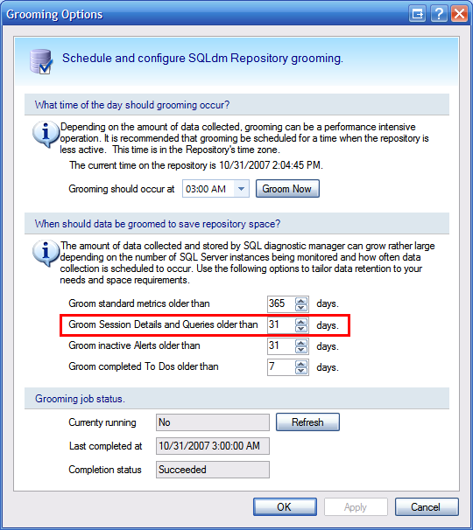
Grooming Options Dialog

Browsing historical snapshots
The most significant user interface enhancement for this feature is the History Browser. The following sub-sections will highlight typical use cases associated with the History Browser.

Displaying the History Browser
Since historical snapshots are server specific, the user must first navigate to a monitored SQL Server instance via the Servers tree or something other method. Once in server view mode, the History Browser can be displayed from any view that supports historical snapshots. A new ‘History’ group will be added to the ribbon for each of the supported views. The following screenshot illustrates the new ‘History’ group:

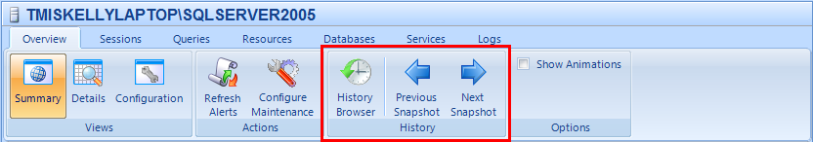
The new History Group

To display the History Browser, one must simply click the History Browser button. This button will be a state button, meaning that if the History Browser is displayed, it would show as checked, much like the Summary view in the same screenshot. Once selected, the History Browser will display, docked on the right-hand side of the desktop client as shown in the screenshot below.

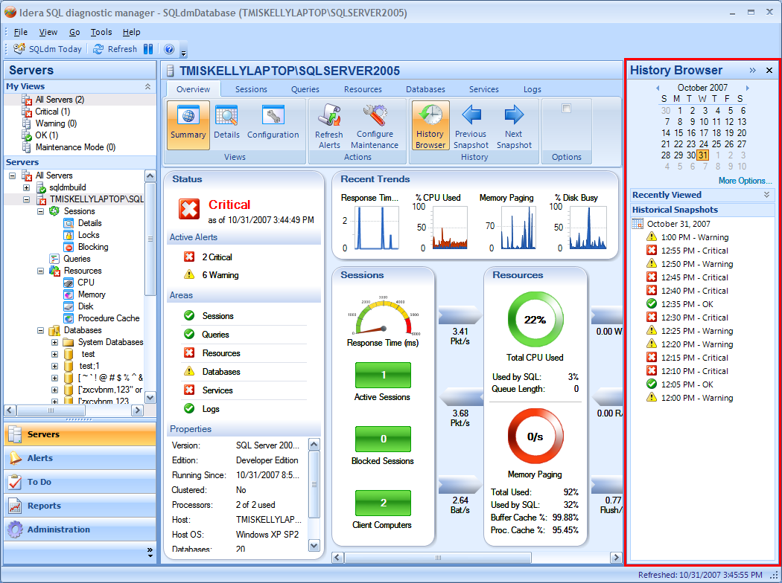
The History Browser (Docked)

Browsing historical snapshots
Now let’s take a closer look at the features of the History Browser in the screenshot below. The main objective of the History Browser is to provide an interface that allows the user to quickly get to a snapshot of interest. Since snapshots are by definition collected at some point-in-time, the first level of filtering is provided as a calendar. This allows the user to quickly select the day for which to show snapshots. When a target date is selected, the snapshots for that date will show in the Historical Snapshots tree.
More filtering options can be specified by clicking the “More Options…” link, located below the calendar. These options will include the ability to filter for a window of time, specified as “From Time” and “To Time.” The idea here is that due the number of collections that can occur on a given day (240 at a default 6 minute refresh interval), users will typically want to only look at a specific window of time. The most likely scenario would be when a DBA is contacted and informed of a problem that seems to be occurring at some time of the day, but no alert has been raised to indicate there was a problem around that time. The filters shown in the “More Options” dialog are applied each time a new day is selected in the calendar. This makes it very easy for the user to quickly see the same window of time over a number of days. By default, we will specify 8:00am to 5:00pm as the window of time.
Historical snapshots are listed in reverse chronological order, with the most recent being on top of the list. The reason for doing this is so that when viewing snapshots from the current day, new snapshots can be added to the top as they are collected, assuming the window of time specified in “More Options” does not filter them out.
Only one day can be selected at a time. This limitation is partially due to limiting the amount of data retrieved from the repository, but it’s also to reduce the amount of data presented to the user since the screen real estate is pretty limited.
Each time a day is selected, a link to the snapshot is added to the top of the Recently Viewed list. This allows the user to quickly compare specific snapshots on different days, or simply have a reference list of snapshots to go back to if necessary without having to navigate back to a previous day or point-in-time. I’m thinking this list will be limited to the last five viewed snapshots. Since this feature may not appeal to some users who value more screen real estate, the panel can be collapsed/expanded as desired.
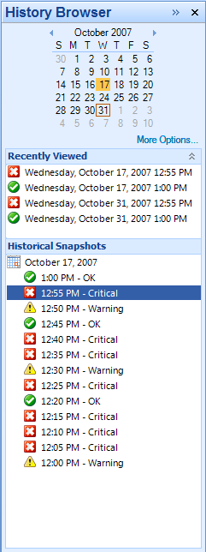
The History Browser

Viewing historical snapshots
Users can mouse over snapshots listed in the Recently Viewed and Historical Snapshots panels to see a tooltip similar to that in the Servers Tree indicating the top three most critical alerts at the time of the snapshot. Once a user has determined the snapshot of interest, displaying the snapshot is simply a matter of clicking the snapshot link in either the Recently Viewed or the Historical Snapshots lists. The following screenshot illustrates the view changes that occur as a result of selecting a historical snapshot.
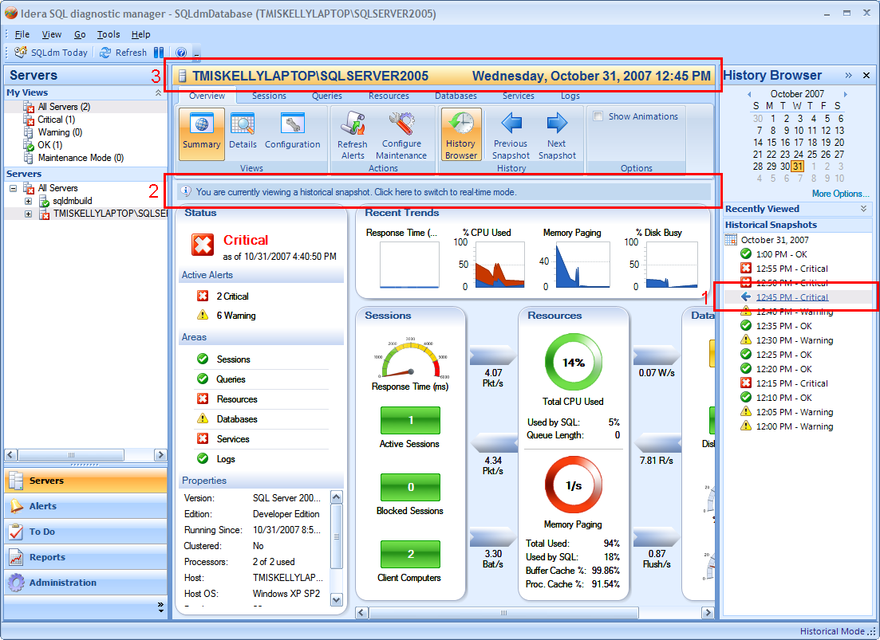
Viewing Historical Snapshots

Notice in red box 1, each snapshot is a link. As the user moves the mouse over the snapshot the severity image changes to a left pointing arrow indicating that when selected, the snapshot will appear in the view to the left. It’s pretty amazing… you’ll have to see it for yourself. When selected, if the current view supports historical snapshots, the view will display data from the snapshot and an informational label (red box 2) will be displayed at the top of the view with a message indicating that the view is currently showing a historical snapshot. The label can be clicked to switch back to real-time mode. In addition, the server title bar (red box 3) will display the historical snapshot time, as well as transform to a brilliant shade of orange to indicate that the server view are in Historical Mode. This mode is also indicated in the main status bar in place of the last refresh time. Sorry, I didn’t put a cool red box around that one, but you can see it in the screenshot.
For views that don’t support Historical Mode, a link label will be presented in place of the view indicating that the view isn’t supported in this mode. This link label can be clicked to switch back to real-time mode. An example of this is shown in the screenshot below.
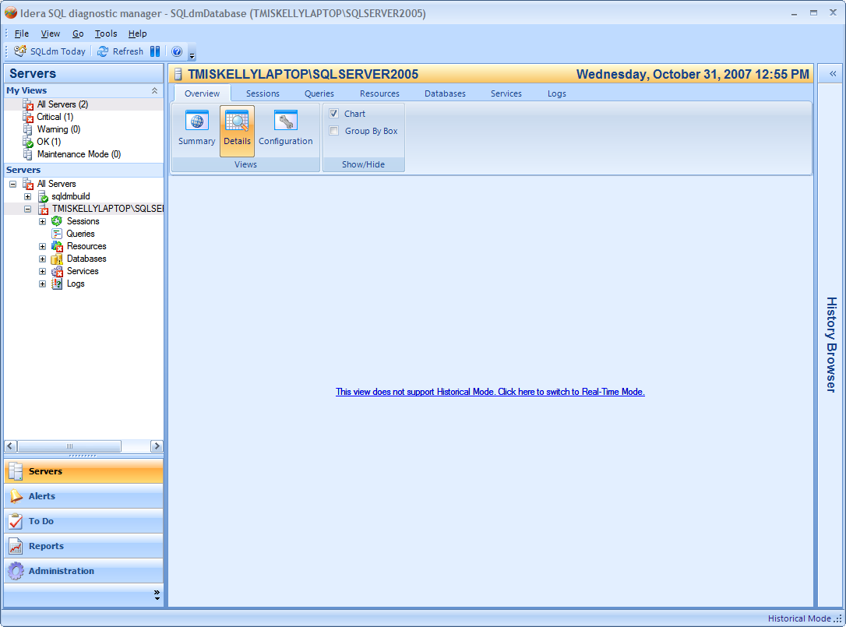
View not supporting History Mode

NOTE: Once a historical snapshot is selected, all views for that server are considered to be in Historical Mode until the user switches back to Real-Time mode. In other words, if the user were to navigate around to other views for a target server that’s in Historical Mode, the other view would attempt to load the specified snapshot.
ANOTHER NOTE: Because Session Details may be groomed out earlier than standard metrics and server state information, Sessions Details, Locks and Blocking may provide a message indicating that no snapshot is available for the selected time. This would be a link label similar to that shown in unsupported views, which the user would be able to click to switch back to real-time mode.

Hiding and Minimizing the History Browser
Our target resolution is still 1024x768. Due to this limitation, screen real estate is critical. Since the History Browser will obviously take up more horizontal space when docked, several mechanisms will be in place to help user conserve space when not actively using the History Browser.
The easiest way to conserve real estate is to close the History Browser. In the screenshots of the Server Summary view illustrated above, you’ll notice that the History Browser has a close button that can be clicked to simply hide the History Browser. Another way to take this same actions is to click the History Browser button in the History group on the ribbon, which is available on the ribbon for any view that supports historical snapshots. This button functions as a toggle to show/hide the History Browser as desired.
Although closing the History Browser is the easiest way to conserve real estate, it’s not necessarily ideal for users that are actively browsing through historical snapshots but can’t afford the loss of screen space. To handle the scenario, users can opt to minimize the History Browser. When the History Browser is expanded, a Minimize button is available in the title bar that when clicked collapses the History Browser to the right-hand side of the desktop client. This takes up only a small portion of the screen (33 pixels to be exact), but still allows the user quick access to the History Browser via a new, super cool, Flyout© technology ☺. The following screenshot illustrates the History Browser when minimized.

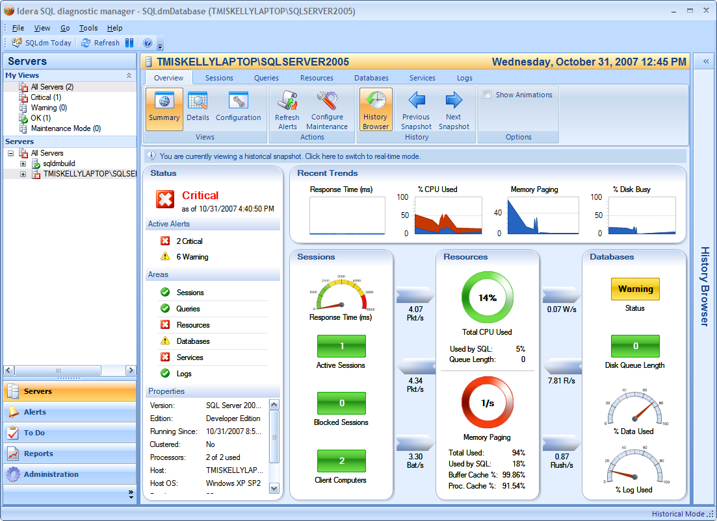
Minimized History Browser

To view the History Browser in Flyout© mode, one must simply click the minimized History Browser panel and the History Browser will flyout to the right without committing any real estate. At this point, the user can operate within the History Browser to filter and select a different historical snapshot. When a snapshot is selected, the History Browser will automatically collapse and the selected snapshot will be presented. I know… mind blowing, right? The following screenshot illustrates the History Browser in Flyout© mode.

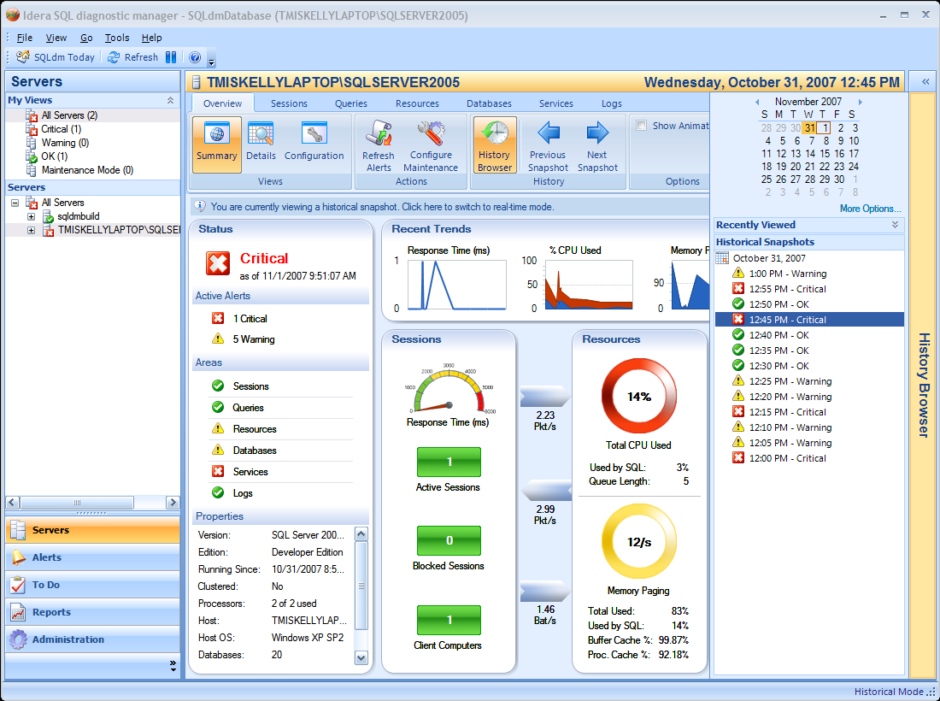
History Browser in Flyout© Mode

Some other quick things to point out... when the History Browser in minimized, an Expand button will be displayed that will allow the user to expand the History Browser to stay available and docked. Also, the user can simply drag the splitter to show the History Browser docked to the size they desire. Also, if the user clicks on a control or window outside of the Flyout© History Browser without selecting a snapshot, the History Browser will automatically minimize under the assumption that the user decided to take other action instead of selecting a new snapshot.

Navigating snapshots quickly
Another feature that’s available to users is the ability to quickly navigate to previous or next snapshots. This feature is exposed in the History group on the ribbon for any view that supports historical snapshots. The following screenshot shows the location of this feature.

The History Ribbon Group

The context of the previous and next snapshot are based the current snapshot being viewed. If in Real-Time mode, the Next Snapshot button would not be enabled; only the Previous Snapshot button would be enabled since we cannot show snapshots into the future.
OPEN ISSUE: Should we show snapshots in the future… that would be awesome and a true differentiator!
In the case that a historical snapshot is currently being shown, both the Previous and Next Snapshot buttons would be enabled. Pressing either of these buttons would take the respective action without the user having to perform any action in the History Browser.
This feature will be great for users that want to watch how the state of a system changes as a problem arises. For example, if a DBA were to receive an alert at some point-in-time, he could select a prior historical snapshot, maybe an hour before the problem occurred, and repeatedly clicks the Next Snapshot button to see how the system state evolved up and until the alert was raised. This should be a huge benefit for diagnosing alerts that occur as a result of other problems on a system.

Switching to Real-Time mode from History Mode
There are two scenarios in which a user may want to switch from Historical Mode to Real-Time Mode.
- If a user has selected a view that supports historical snapshots, an information bar will be presented at the top of the view indicating that a historical snapshot is currently being shown. Clicking on this bar will switch the user back to Real-Time Mode. A screenshot in the previous section illustrates this scenario.
- If a user has selected a view that does not support historical snapshots, a link label will appear in place of the view that will indicate that the view does not support History Mode; the link can be clicked to switch to Real-Time Mode. A screenshot in the previous section illustrates this scenario.

Viewing historical snapshots for specific alerts
One of the most important scenarios for viewing a historical snapshot is when a notification has been received indicating that an alert has been raised for a monitored SQL Server. In this case, the user may want to view the state of the system at the point-in-time of the alert. To accommodate for this scenario, new context menu options have been added to the SQLdm Alerts view grid. The screenshot below shows the new context menu options.

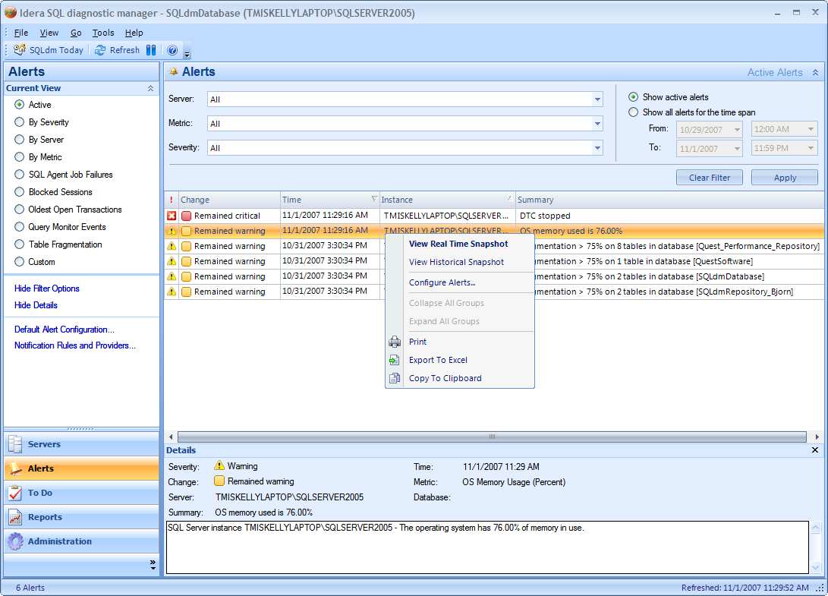
Alert Context Menu

Two new options have been added:
- View Real Time Snapshot
  - Although this option was not on the context menu in the previous version of SQLdm, it was the default click-through behavior, and still is. It is shown in bold because it’s the default, and when selected on the context menu, the user is taken to the associated view with a real time snapshot loaded.
- View Historical Snapshot
  - This option will only appear for alerts which have associated views that support historical snapshots.
  - Selecting this option will navigate the user to the associated view for the alert, but rather than showing a real time snapshot, a historical snapshot will be loaded based on the time of the alert. There are a couple of things to note in this scenario:
    - If no snapshot exists at the point-in-time of the alert, a link label will indicate that’s the case and the user can click the label it to switch to real time mode.
    - If a snapshot does exist, the snapshot is loaded, and the snapshot is added to the Recently Viewed list in the History Browser. Note that the filter applied in the History Browser will not change, meaning the snapshots currently listed in the Historical Snapshots list will not change.

Installation and Upgrade
We will be upgrading to Infragistics NetAdvantage 7.3 for this feature. Since the binary names of the components have changed, this will require a major upgrade of the desktop client component.

Permissions and other Required Configuration
No additional permissions or configuration other than that specified in the User Interfaces section will be required for this feature.

Licensing Issues
No additional license requirements are required for this feature.

Dependencies

Dependencies on Idera Software
No additional dependencies on other Idera software will be required for this feature.

Third-Party Software Required on the Customer Machine
- Infragistics NetAdvantage 7.3

Third-Party Software Required Internally

- Infragistics NetAdvantage 7.3

Internal Design

Architecture

Historical Snapshot Collection
In order to complete the historical snapshot as defined by this feature, several enhancements will be made to the existing scheduled refresh:
- The existing Server Details probe will be modified to include any missing data that is displayed in the following views:
  - Overview > Details
    - Audit Level
    - Login Mode
  - Sessions > Summary
  - Database Lock Requests
  - Database Lock Timeouts
  - Database Lock Deadlocks
  - Database Lock Waits
  - Database Lock WaitTime
  - Database Lock Oustanding Granted
  - Database Lock Outstanding Waiting
  - Database Lock Outstanding Converted
  - Extent Lock Requests
  - Extent Lock Timeouts
  - Extent Lock Deadlocks
  - Extent Lock Waits
  - Extent Lock WaitTime
  - Extent Lock Oustanding Granted
  - Extent Lock Outstanding Waiting
  - Extent Lock Outstanding Converted
  - Key Lock Requests
  - Key Lock Timeouts
  - Key Lock Deadlocks
  - Key Lock Waits
  - Key Lock WaitTime
  - Key Lock Oustanding Granted
  - Key Lock Outstanding Waiting
  - Key Lock Outstanding Converted
  - Latch Lock Requests
  - Latch Lock Timeouts
  - Latch Lock Deadlocks
  - Latch Lock Waits
  - Latch Lock WaitTime
  - Latch Lock Oustanding Granted
  - Latch Lock Outstanding Waiting
  - Latch Lock Outstanding Converted
  - Page Lock Requests
  - Page Lock Timeouts
  - Page Lock Deadlocks
  - Page Lock Waits
  - Page Lock WaitTime
  - Page Lock Oustanding Granted
  - Page Lock Outstanding Waiting
  - Page Lock Outstanding Converted
  - RID Lock Requests
  - RID Lock Timeouts
  - RID Lock Deadlocks
  - RID Lock Waits
  - RID Lock WaitTime
  - RID Lock Oustanding Granted
  - RID Lock Outstanding Waiting
  - RID Lock Outstanding Converted
  - Table Lock Requests
  - Table Lock Timeouts
  - Table Lock Deadlocks
  - Table Lock Waits
  - Table Lock WaitTime
  - Table Lock Oustanding Granted
  - Table Lock Outstanding Waiting
  - Table Lock Outstanding Converted
  - Total Lock Requests
  - Total Lock Timeouts
  - Total Lock Deadlocks
  - Total Lock Waits
  - Total Lock WaitTime
  - Total Lock Oustanding Granted
  - Total Lock Outstanding Waiting
  - Total Lock Outstanding Converted
  - Allocation Unit Lock Requests
  - Allocation Unit Lock Timeouts
  - Allocation Unit Lock Deadlocks
  - Allocation Unit Lock Waits
  - Allocation Unit Lock WaitTime
  - Allocation Unit Lock Oustanding Granted
  - Allocation Unit Lock Outstanding Waiting
  - Allocation Unit Lock Outstanding Converted
  - Application Lock Requests
  - Application Lock Timeouts
  - Application Lock Deadlocks
  - Application Lock Waits
  - Application Lock WaitTime
  - Application Lock Oustanding Granted
  - Application Lock Outstanding Waiting
  - Application Lock Outstanding Converted
  - Heap Lock Requests
  - Heap Lock Timeouts
  - Heap Lock Deadlocks
  - Heap Lock Waits
  - Heap Lock WaitTime
  - Heap Lock Oustanding Granted
  - Heap Lock Outstanding Waiting
  - Heap Lock Outstanding Converted
  - MetaData Lock Requests
  - MetaData Lock Timeouts
  - MetaData Lock Deadlocks
  - MetaData Lock Waits
  - MetaData Lock WaitTime
  - MetaData Lock Oustanding Granted
  - MetaData Lock Outstanding Waiting
  - MetaData Lock Outstanding Converted
  - Object Lock Requests
  - Object Lock Timeouts
  - Object Lock Deadlocks
  - Object Lock Waits
  - Object Lock WaitTime
  - Object Lock Oustanding Granted
  - Object Lock Outstanding Waiting
  - Object Lock Outstanding Converted
  - Resources (sans Procedure Cache)
- Several existing Sessions probes will be included in a separate batch run by the scheduled refresh. These probes include:
  - Sessions Details
    - This probe includes data used to populate the Sessions > Blocking By Sessions view.
  - Sessions Locks
    - This probe includes data used to populate both the Sessions > Locks view as well as the Sessions > Blocking By Locks view.

It’s important to note that the new Sessions probes included in the scheduled refresh will be an isolated portion of the schedule refresh with its own error handling. The main reason for this separation is that the failure of the Sessions probes should not cause the overall scheduled refresh to fail. Any failure will be logged and an alert will be raised providing details about the failure.
In the case that Sessions data is successfully collected, it will be passed to the Management Service for storage in the Repository. No new alerts are being added for this data. It should also be noted that the format of the data prepared by the probe will stay the same as it is in the current product. The idea here is that by keeping the data in the current format, the cost/risk of populating the existing views from historical snapshots should be greatly reduced.
OPEN ISSUE: At this point no performance testing has been performed to determine the impact of collecting all sessions and all locks with no filtering. We may have to address default filtering if performance results are poor. This will be difficult to determine until we get the Sessions probes moved into the scheduled refresh.

Historical Snapshot Storage
Scheduled collection data will be returned from the Collection Service to the Management Service using the same API as in the current version of the product. However, the data returned will also include Sessions and Locks data. The Management Service will handle raising alerts in the case that an error occurred while collecting Sessions and Locks data, but no other alerts will be raised as a result of the new data.
The process for generating alerts will not change; however, saving general statistics will need to take the missing data outlined in the previous section into account. This will require adding columns to the ‘ServerStatitics’ table for each of these missing items, as well as accommodating for these parameters in the ‘p_InsertServerStatitics’ stored procedure.
OPEN ISSUE: Should we break the new statistics out into a separate table to deal with upgrade more easily.
Once this alert and statistics processing is complete, the server state graph will be generated, rather than generating the state graph on a scheduled basis. The state graph represents an overview of the state of a given server including the following information:

- Server version info
- Number of active critical and warning alerts
- Top three most critical alerts for each area
- Top three most critical alerts for each database

In the current version of the product, state graphs for all servers are generated every minute; however, this will change to generating a state graph for each server upon completion of a scheduled refresh. This state graph will be cached by the Management Service for future reference by the desktop client. The copy of the state graph will then be made and the database level alerts will be stripped. This copy will then be stored in a separate table named ‘ServerActivity’ along with the Sessions and Locks data. The following schema will be used for this table:

- ‘ServerActivity’ Table Schema
  - SQLServerID (FK, int, not null)
  - UTCCollectionDateTime (datetime, not null)
  - StateOverview (ntext, null)
  - Sessions (image, null)
  - Locks (image, null)

A new stored procedure named ‘p_InsertServerActivity’ will be added to support saving this new data in the Repository.

Grooming Historical Snapshots
In order to accommodate for the new grooming options associated with this feature, a new Internal_Value will be available in the ‘RepositoryInfo’ table named ‘GroomActivity’. This value will only be included if it’s something other than the default 31 days.
The grooming stored procedure used to retrieve this data, ‘p_GetGrooming’, will take this new data into account, as well as the stored procedure which actually executes the grooming, ‘p_GroomRepository’. Based on the ‘GroomActivity’ value, the ‘ServerActivity’ table will be groomed appropriately on each execution of the grooming job, which is scheduled to run once daily.

Viewing Historical Snapshots
In order to display a historical snapshot in a supported view, the related data must be retrieved from the Repository. Several new stored procedures will be added to accommodate for this:
- p_GetSnapshots(SQLServerID, FromUTSnapshotTime, ToUTCSnapshotTime)
  - This stored procedure will be called to populate the Historical Snapshots list in the History Browser for a given date/time range.
  - This stored procedure will return ServerActivity.StateOverview data points for the range specified.
- p_GetServerSummary(SQLServerID, UTCSnapshotTime, PreviousDataInMinutes)
  - This stored procedure will be called by the Overview > Summary view when a historical snapshot is selected.
  - This stored procedure returns for following data:
    - ServerActivity.StateOverview
    - All server statistics shown in the Overview > Summary view
    - The last n data points (based on PreviousDataInMinutes) for the Recent Trends graphs shown in the Overview > Summary view
  - This stored procedure will return no data if the ServerActivity.StateOverview data is NULL.
- p_GetSessionsSummary(SQLServerID, UTCSnapshotTime, PreviousDataInMinutes)
  - This stored procedure will be called by the Sessions > Summary view when a historical snapshot is selected.
  - If a snapshot does not exist at the time specified, no data will be returned.
  - If a snapshot exists at the time specified, this stored procedure returns all data necessary to populate the Sessions > Summary view, including all data points back to the PreviousDataInMinutes.
- p_GetSessions(SQLServerID, UTCSnapshotTime, PreviousDataInMinutes)
  - This stored procedure will be called by the Sessions > Details and Blocking By Session views when a historical snapshot is selected.
  - If a snapshot does not exist at the time specified, no data will be returned.
  - If a snapshot exists at the time specified, this stored procedure returns all data necessary to populate the supported Sessions > Details and Blocking By Session views, including all data points back to the PreviousDataInMinutes.
- p_GetLocks(SQLServerID, UTCSnapshotTime, PreviousDataInMinutes)
  - This stored procedure will be called by the Sessions > Locks and Blocking By Locks views when a historical snapshot is selected.
  - If a snapshot does not exist at the time specified, no data will be returned.
  - If a snapshot exists at the time specified, this stored procedure returns all data necessary to populate the supported Sessions > Locks and Blocking By Locks views, including all data points back to the PreviousDataInMinutes.
- p_GetResourcesSummary(SQLServerID, UTCSnapshotTime, PreviousDataInMinutes)
  - This stored procedure will be called by all supported Resources views (sans the Procedure Cache view) when a historical snapshot is selected.
  - If a snapshot does not exist at the time specified, no data will be returned.
  - If a snapshot exists at the time specified, this stored procedure returns all data necessary to populate the supported Resources views, including all data points back to the PreviousDataInMinutes.
  - NOTE: This data will be cached by the desktop client and the timestamp checked when switching among Resources views before re-running the stored procedure to ensure the best performance.

Since the structure of the data returned by the stored procedures is the same as was returned by the real time probes, the views will populate in the same fashion. This should greatly reduce the complexity and risk of implementation.
Views that do not support displaying historical snapshots will display an informational message as outlined in the screenshots in the User Interfaces section.
OPEN ISSUE: Depending on how performance testing works out, p_GetServerSummary, p_GetSessionsSummary and p_GetResourcesSummary may be combined since some of the data is duplicated and the user will likely switch among the associated views.

Installation Issues
The only installation issues of concern for this feature will be the upgrade for the new Infragistics NetAdvantage 7.3 components. This will require a major upgrade for the SQLdm application installer.
There are no other configuration upgrade issues known at this time.

Schedule

Work Breakdown and Sizings

Component | Who | Sizing
Collection Service – Add missing data to Server Details probe | Vicky | 3
Collection Service – Add Sessions and Locks probes to scheduled collection | Vicky | 5
Management Service – Changes state graph update process | Kurt | 2
Management Service – Process new data and alerts | Kurt | 2
Repository – Add new table and stored procedures | Kurt | 2
Repository – Upgrade scripts changes | Vicky | 1
Desktop Client – Create History Browser control and dock logic | Trent | 5
Desktop Client – Populate historical snapshots in History Browser | Trent | 2
Desktop Client – Populate Overview > Summary with snapshot | Trent | 2
Desktop Client – Populate Overview > Details with snapshot | Trent | 4
Desktop Client – Populate Sessions > Summary with snapshot | Trent | 2
Desktop Client – Populate Sessions > Details with snapshot | Trent | 2
Desktop Client – Populate Sessions > Locks with snapshot | Trent | 2
Desktop Client – Populate Sessions > Blocking with snapshot | Trent | 2
Desktop Client – Add handing for unsupported views | Trent | 2
Desktop Client – Add alert navigation to associated historical snapshot view | Trent | 2
Unit and Integration Testing | Trent | 3
Total |  | 43

Areas of Risk
Several areas of risk should be considered for this feature:

- We have not performed any performance tests on scheduled collection running Sessions probes. This is difficult to do until we actually do the work to move the probes into scheduled collection. A contingency plan would be to provide default filtering for probes were appropriate in order to reduce the number of sessions, locks, etc. that may be collected. RISK: Medium
- Due to the new Sessions probes included in the schedule refresh and the dynamic nature of this data (variable session lists, locks, etc.), an unknown amount of new data will be transmitted to the Management Service for storage. This will increase the workload of the Management Service and could cause bottlenecks that we’ll have to address. RISK: Medium
- Our intent is to handle the data returned by the Sessions probes in much the same way as it is now in the desktop client. This should keep scope reasonable. However, if for some reason we run into problems storing/retrieving/versioning this data in its existing binary format, we may have consider other alternatives. RISK: Low

Quality Assurance Considerations

Overview
The following QA considerations should be made for this feature:

- Since our standard scheduled collection will be effected by the new Sessions probes, plus minor changes to collect data missing from our Server Overview, thorough testing of scheduled collection should be performed. IMPACT: Medium
- Since the data returned by the Sessions probes is dynamic in nature, tests should be performed with variable sessions established to monitored SQL Servers to ensure that the Collection and Management Service can handle the additional load. Sessions should also be configured to cause various blocking scenarios to ensure that the Locks and Blocking view are appropriately populated. IMPACT: High
- The main goal is for the views that support historical snapshots to appear the same as if they were showing real-time data. This should be a good mechanism for testing collected data. IMPACT: Low
- All existing real-time views will have to be modified to handle historical snapshots, whether supported or not. This will require QA to test each of those views in Real-Time and History mode to ensure that they behave as expected. IMPACT: High
- Since new grooming options of have been added for the new Sessions data (these options are also tied to the existing Query Monitor data), the grooming job should be tested to ensure that data is appropriately grooming based on the number of days specified. IMPACT: Low

Developer-Created Unit Tests
All unit tests will be performed manually. At some point we may add automated unit tests to stress the new sessions probes that will be added to the scheduled refresh, but that automation is not within the current scope.

Documentation Considerations
Since this is a major new feature to SQLdm, it should be fully documented so the functionality and behavior are clear to the user. The User Interface section outlines most of these critical user specifics.

Bibliography

